Aim :
To create and set up a Zoho Creator account and explore its platform architecture, development environment, user interface, applications, forms, reports, pages, workflows, and other major components.

Definition:
Zoho Creator is a low-code application development platform that allows users to create, customize, deploy, and manage business applications with minimal manual coding. It provides visual development tools such as forms, reports, pages, workflows, and dashboards to simplify application development.

Procedure:
- Open a web browser and visit the Zoho Creator website.
- Create a new Zoho Creator account using an email address or an available sign-in option.
- Complete the account verification process, if required.
- Log in to the Zoho Creator platform.
- Explore the Home/Applications section of the platform.
- Create a new application using a blank application or an available template.
- Explore the application development environment.
- Examine the Forms section used to collect and store data.
- Explore Reports for displaying and analyzing stored data.
- Explore Pages for designing customized application interfaces and dashboards.
- Examine Workflows for automating tasks and business processes.
- Explore the application settings, users, permissions, and other configuration options.
- Observe the platform's visual development interface and navigation structure.
- Test the created application and examine how data moves between forms, reports, pages, and workflows.

Output:

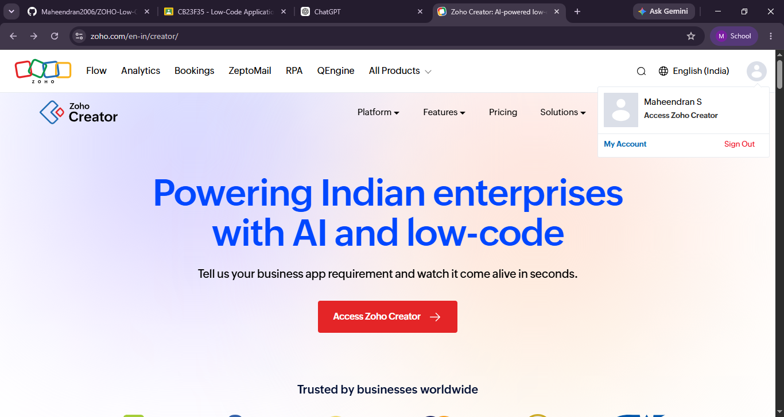

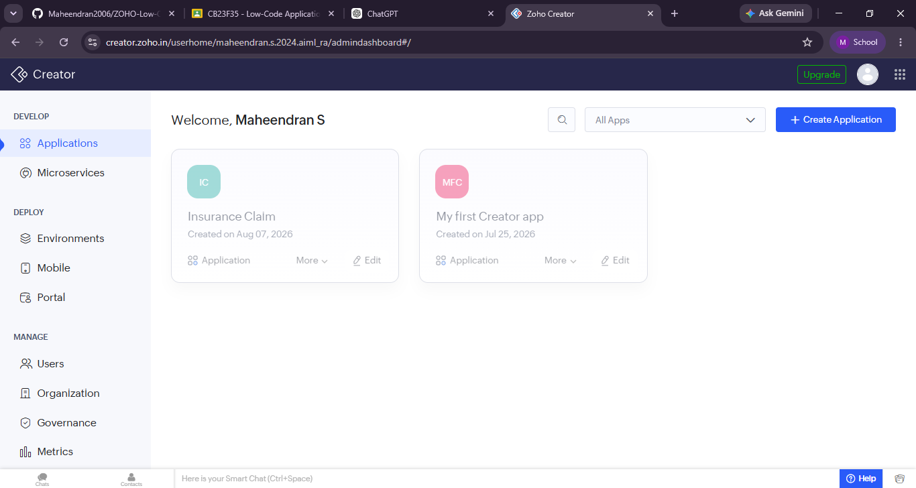
Result:
The Zoho Creator account was successfully set up, and the major components of the platform architecture and interface were explored. The functions of Forms, Reports, Pages, Workflows, Deluge, Settings, Users, and Integrations were identified. Thus, the basic working environment of the Zoho Creator low-code development platform was successfully understood.

